**Sandwich Cookies and Plate Tectonics**

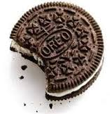 **Theory of Plate tectonics**

The theory of plate tectonics states that the **lithosphere** is made up of plates that move. This theory also explains why and how earthquakes and volcanoes are likely to occur within certain areas as well as how new crust forms along the ocean floor. These plates are thought to float across the t op of the **asthenosphere**. The **asthenosphere** is the layer just below the **lithosphere**.

While in motion the plates interact with each other at their **boundaries**. The interactions at the boundaries of the plates, refers to how the plates interact at their edges. Plates interact with one in other in several ways. The main types of interactions are **convergent**, **divergent** and **transform** boundaries. Use cookies for to demonstrate a sliding plate over the asthenosphere and the following types of boundaries.

Plates move in three basic ways. Let’s look at them one by one.

Upper Cookie

Creamy Filling

Lower Cookie

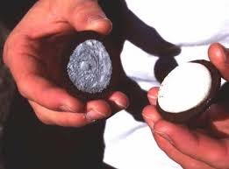Choose a cookie. **Don’t eat it…yet!**

1. First, carefully remove the upper cookie (a “twisting” motion is required).
2. Slide the upper cookie over the creamy filling. This motion simulates the movement of a rigid ________________________ plate over the softer ____________________________.
3. Next, break the upper cookie in half. As you do so, listen to the sound it makes. What does that breaking represent? (Hint: what do we call it when the plates move past each other and send energy waves out?) _______________________________________________________

Divergent Boundaries

Let’s look at divergent plate boundaries. Divergent means _____________________________________.

1. Now, using the cookie you just broke, put the two pieces on top of the icing, touching each other and slide the two pieces apart while gently push down on both. What happens to the filling? ________________________________________________________________________
2. The creamy filling between the two broken “plates” may tend to flow out of the mid-ocean ridge, and creates new __________________________________.
3. What features are formed at divergent boundaries? ________________________________________________________________________________

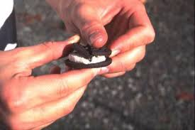Convergent boundaries

Now let’s look at convergent plate boundaries. Convergent means ______________________________.

1. Twist the upper cookie off and break it in half. Place the two pieces on the icing about an inch apart. Slowly push the two halves together as you gently push down. What happens to the filling as the plates slide together? ______________________________________ ______________________________________
2. What does the filling represent? ______________________
3. What happens to the cookies as they push against each other? ___________________________
4. What features are formed at divergent boundaries? ________________________________________________________________________________
5. If one cookie (plate) moves underneath the other we call it _____________________________.

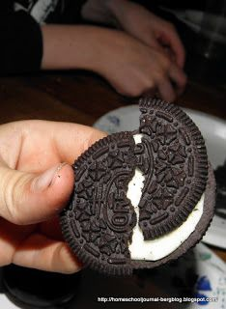Transform boundaries

1. Now let’s look at a transform plate boundary. Try sliding the two cookie pieces laterally past one another, over the creamy filling. What do you notice about the cookie edges? ______________________________________________________________
2. The edges of the plates may stick together and release, what is the release of energy called? _______________________________________________
3. What feature is formed at transform boundaries? ___________________

Now Go to:

<https://www.learner.org/interactives/dynamicearth/tectonicsmap/>

1. What are 3 pairs of plates with convergent boundaries?
2. What are 3 pairs of plates with divergent boundaries?
3. What are 3 pairs of plates with transform boundaries?
4. Now try the Plates & Boundaries Challenge! Write your best score! __________/22